MACH4METAL

metalworking machinery
Transito 21
6909 DA BABBERICH Netherlands
Tel. +31 (0)316-247123
Fax: +31 (0)316-247956
info@mach4metal.com
www.mach4metal.com

Bank No : 66.52.13.883
IBAN : NL33 INGB 0665 2138 83
BIC : INGBNL2A

Pressbrake LVD PPEB Easy-Form

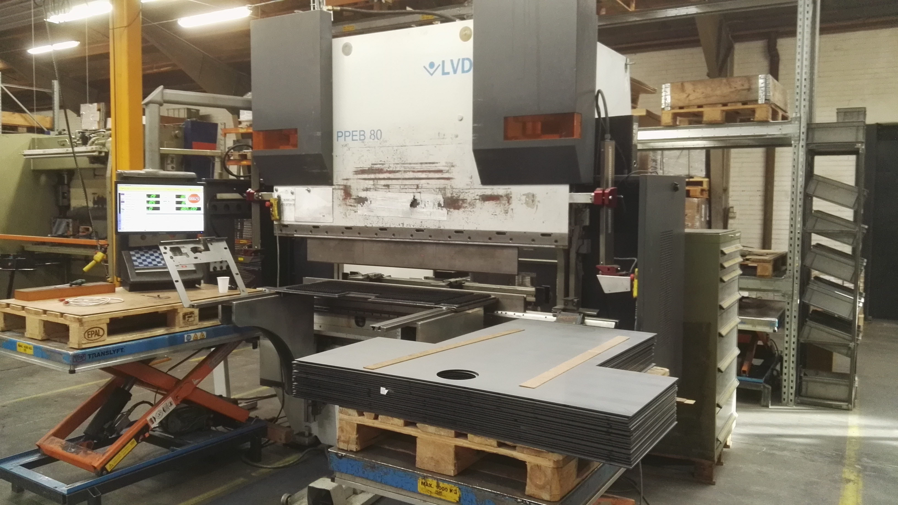
- Make : LVD (Belgium)
- Typ : PPEB 80/20
- Mach. No. : 28110
- Age : 2001

- Max. Force : 80 T
- Bending length : 2000 mm
- Between column : 1550 mm

- Stroke : 200
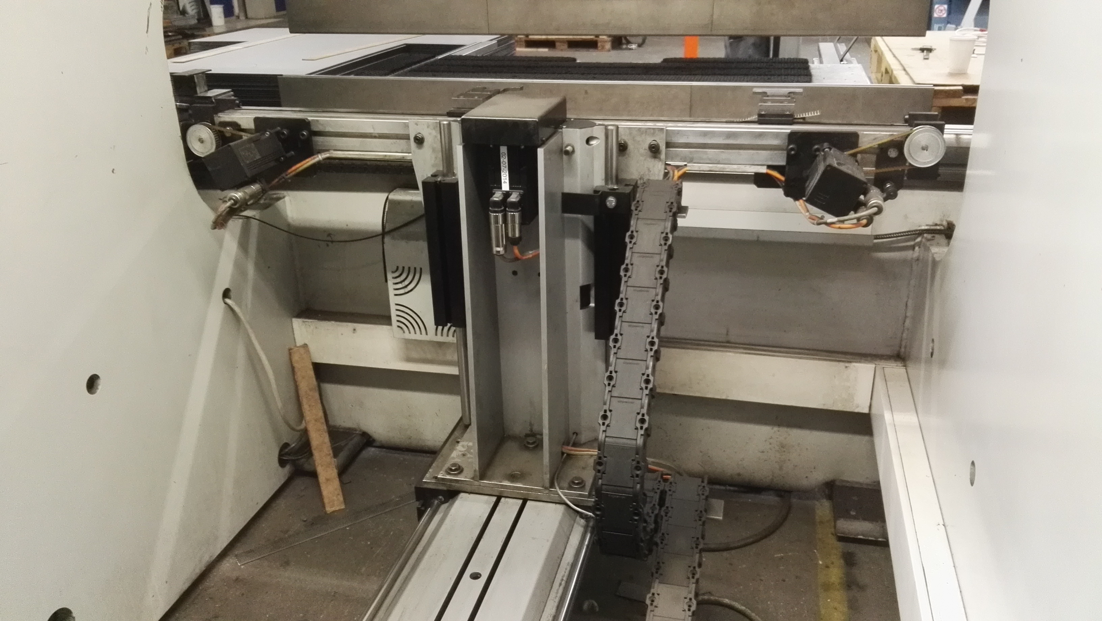
- Dis. Table – ram : 400
- Throat : 400
- Table width : 120

- Approch speeds : 130
- Working speeds : 10
- Return speeds : 113

- Cadman B CNC Controll
- Y1 / Y2 / X / R / Z
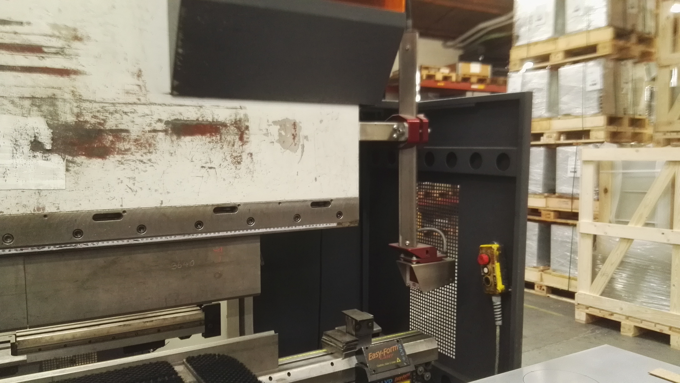
- CNC V – Axis Crowning
- Easy Form measuring system
- Lazer safe protectie

- Dimensions
- Length : 3.000
- Width : 2.300
- Height : 2.700
- Weight : 5.700

Please Note: The above information has been obtained to the best of our ability and belief from, and from the manufacturers where possible. It is given in good faith, but its accuracy can not be guaranteed. Accordingly, it will not form a representation or constitute contractual terms. We advise you to check any vital details!

